Proposal to the:
Minister of Interior and Municipalities (MOIM) of the
Republic of Lebanon

for the:
NCSIS
National Civil State Information System
SYSTEM DESCRIPTION

Beirut, Lebanon 10. September 2003

Prepared by:

..........
System Architect
Systems Development, .......................................
e-mail:

.........................................
IT Security architect
Systems Development, ............................................
e-mail:

............................
Norway

Internett:
Table of Contents
0 System Description 4
1 NCSIS Core Services 7
1.1 Establishment of Civil State Register 7
1.2 Registration 8
1.3 Verification. 9
1.4 Extraction 10
1.5 Statistics 10
1.6 Auditing 11
2 NCSIS Users 12
2.1 Citizens 12
2.2 Employees 13
2.3 Agencies 13
2.4 Other 13
3 NCSIS Channels 14
4 NCSIS interface services 15
4.1 Portal 15
4.2 Integration layer 15
5 NCSIS platform services 16
5.1 Application Server 16
5.2 Other tools 16
6 Security 17
6.1 Security Architecture 17
6.2 Integration - XML/Web Services Security 19
6.3 Single Sign-On 20
6.4 Other Security elements 20
6.5 IDS 21
6.6 Platform Security 21
6.7 Public Key Infrastructure (PKI) (Optional) 22
6.7.1 Initial NCSIS PKI 22
6.7.2 Time-stamping and archiving service 22
7 NCSIS Advanced services 24
7.1 Publishing 24
7.2 Analysis 24
7.3 Rule engine and workflow 25
7.4 Document Management 26
7.5 Demographic service 26
7.6 Digital geographical information systems 28
8 MOIM operation 30
8.1 User administration 30
9 System Management 32
9.1 System administration 32
10 IT infrastructure 34
11 Quality and Processes 37
11.1 Microsoft Solution Framework 38
11.2 Rational Unified Process 39

System Description
This document is prepared based on the NCSIS Project Initiation document supplied by the Ministry of Interior and Municipalities (MOIM). This document reflects ......................... view on a possible implementation of NCSIS. Parts of the system described are likely to be adjusted during the project based on improved understanding of MOIM’s requirements. This will especially be the fact during the envisioning phase when the details of the new system are to be decided.

The National Civil State Information System (NCSIS) will fulfill MOIM’s intentions to integrate all computerized functions of MOIM showed in the figure below. The NCSIS will in an efficient way support the day-to-day operations in the MOIM. To provide support for the eGovernment ambition, the system can integrate on a business level with other public systems in Lebanon.

The NCSIS will be a trusted platform for mission-critical operations. The NCSIS Platform is an open, standards-based platform for developing and running enterprise-class applications and Web Services. It consists of Application Server, Portal technology, and the comprehensive integration services provided by the Integration layer.

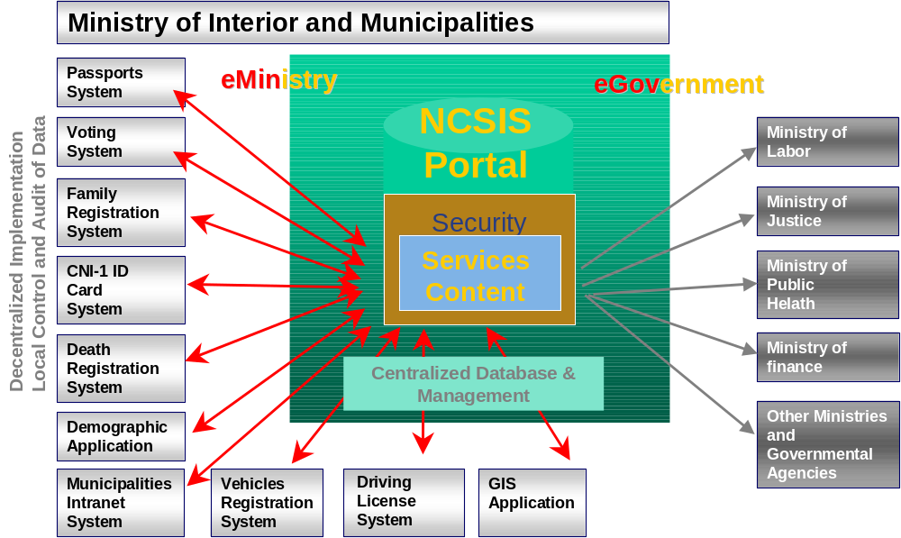
Figure 1 Integrated NCSIS overview
Access to NCSIS will be provided through an Intranet Portal. All necessary security precautions will be implemented to prevent un-authorized reading and updating of information. NCSIS will be designed as a centralized database under full control of MOIM. Information may, however, be audited and entered from local sources (casas, municipalities, citizens), according to Lebanese law and procedures/regulations established by MOIM.

Current MOIM systems (Passport System, Vehicle Registration system, etc.) will be integrated with the central NCSIS Civil State Data Base by bi-directional links (provide information to-/receive information from-). Functionality in the existing systems will be modified accordingly.

Other ministries and agencies’ computer systems may receive information from the NCSIS data base through a generic XML/web service interface and business integration.

Figure 2 gives an overview of the different layers of the system and its surroundings. The following chapter will give an overall description of the different layers, services and functions.

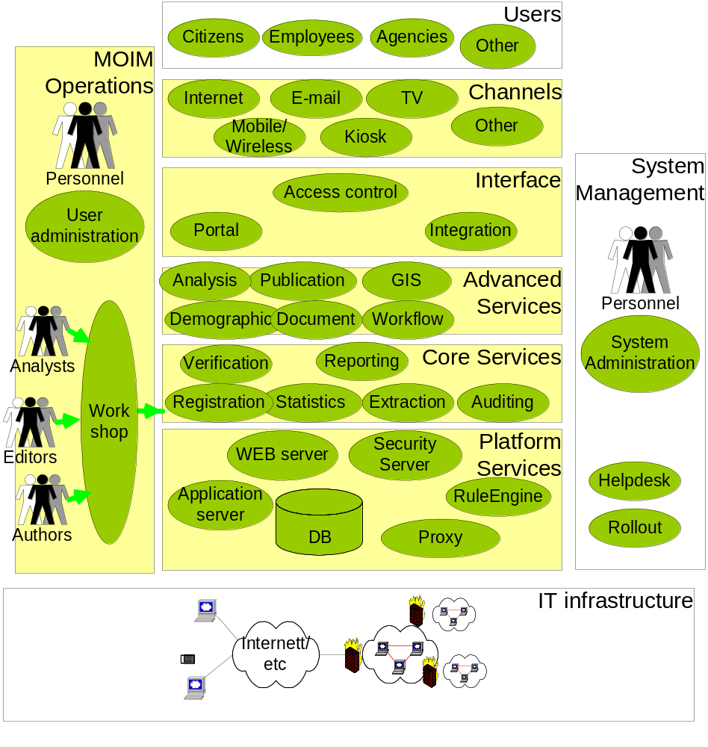

Figure 2 NCSIS System overview
The NCSIS will serve the citizens, employees and systems with the following services and functions:
- Intranet
  - E-mail
  - Intranet browsing
- New Civil State Register (CSR)
  - Early CSR Registration
  - Data conversion mech. and procedures
  - CSR Registration
  - CSR Verification
  - CSR Extraction
  - CSR Audit
  - CSR Statistics
  - Death and Family integrated in CSR
  - Workflow and rule engines
- CSR Integrated with other MOIM system
  - CNI-1 ID-card and archive system
  - Voting System
  - Passport system
  - Driving license system
  - Vehicles Registration System
  - Central Adm. Of Statistics
- CSR Generic Integration/ Import and export (new systems)
- Business Functions (Integration with new systems)
- NCSIS Advanced services Information Handling
  - Publishing System
    - Public Information
    - Official Information
  - Content management
  - Document management
  - Geographical Information System
- NCSIS Advanced services planning support
  - Analysis tools
  - Demographic System
- System Management
  - System Administration
  - Technical Help desk
- MOIM operations
  - Security administration
    - User Administration
    - External System access administration.
  - Operation of NCSIS Enhanced Information and planning tools
  - Operation of the NCSIS business rules
- Security
  - Authentication.& Access control
  - Firewalls
  - Intrusion Detection System
  - Web Services Security
  - Single Sign-On
  - PKI (optional)
- Productions Facilities SW/HW
  - Duplicated
  - High availability and resilient

NCSIS Core Services

Establishment of Civil State Register
We assume that the NCSIS, beside standard personal, address and family information about the citizens also will include other information pertinent to the responsibility of the MOIM, like passport, driving license and Vehicle ownership data. In addition, a number of information about the citizen can be valuable to include, especially when doing demographic surveys, like education and health status. While educational status should be natural to include, health information may be under more restrictions regarding integration into one register.

The new NCSIS will be established in a number of steps.
First, a new person register must be created based on existing registers that hold citizen state related data. Obvious sources are the databases in the ID card register, existing civil state register, Voting system and the Death registration system. Figure 3 shows the different registers and possible flows of data into the new register and back.
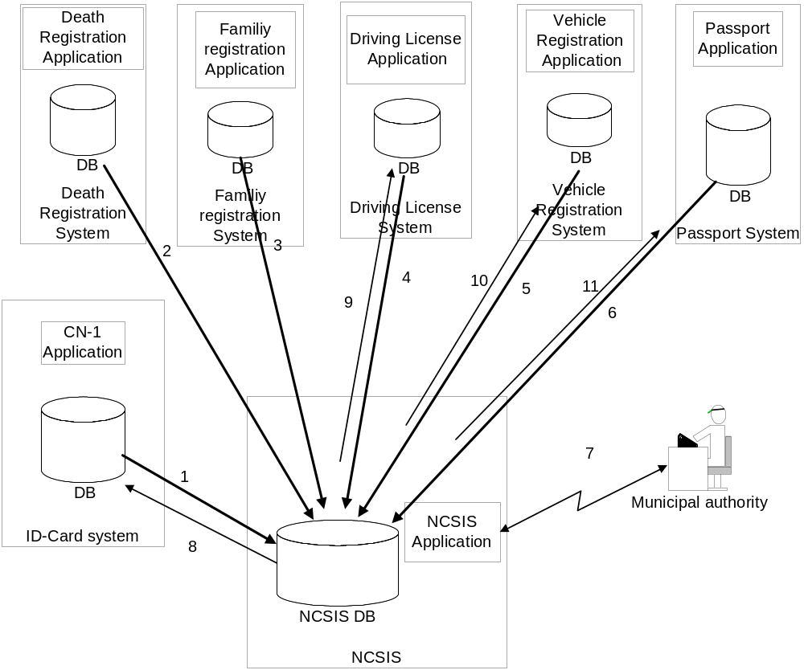
Figure 3 Establishment of National Civil state register

The integration of the information from these systems is done centrally. The process of integrating the data from the different systems into one system depends on the existing dependencies between the different databases and the completeness, consistency and correctness of the data in the different registers. The NCSIS project will use the ID card register as basis for the new person register, other sources must be discussed during the initial project phases.

After the new person register is established together with a new family relation register, other registers, like the Passport register, Driver license register and the Vehicle registration register can be audited to verify the quality of the information in these registers.
The arrow 1 to 6 in Figure 3 illustrates the import of citizen information from the different registers to create an overall person register and family relation register.

The new person register and family register must be audited together with the information in the other registers by each municipal authority based on their manual records and knowledge about their local citizens. The arrow 7 in Figure 3 illustrates this process. The development of the actual auditing process is the responsibility of the project in close co-operation with the people that will do the actual auditing, but the auditing work must be carried out by MOIM / Local authorities.

The auditing process completes the integration of the different databases for each municipality. It can be done as the new database is completed with the data for the citizens in each municipality or when the citizens contacts the local authorities to register new information or changes to existing civil state. The actual auditing process will be defined during the project. After the auditing process is complete (either person by person, or in bulk), the ID card system, Driver License system, Vehicle Registration Register and Passport register is updated with information about valid citizens, ie, the systems can remove or revoke their registrations for people who have died etc. The arrows 8-11 in Figure 3 illustrate the updating of the different systems.

The NCSIS project has also included an early registration application with a similar input screen as the new register. The application will allow the local authorities to register information (new persons (birth), persons not included in the ID card register, changes in status, etc.) about persons before the new register is implemented. These early registrations will be stored in a database and integrated into the NCSIS in the first version of the new register. The purpose of this application is early registration and audit of data to speed up the total process to establish a well functioning NCSIS.

For information on the integration of the MOIM systems please refer to chapter 4.2.

Registration
The basic function of the new NCSIS system is to receive and hold updated information about the citizens. To do this the citizens and local authorities must register important changes in the citizen’s civil state into the new system. The following is a list (not complete) of events that is registered.
- Birth,
- Marriage
- Divorce
- Death
- Address change
- ID card status
- Driving license status
- Changes to civil state
- Emigration
- Immigration

Today, the registrations is done by filling in the appropriate form and delivering this form together with required documentation to the local authority, which then process the information depending on the type of registration. The forms will not disappear, but the handling of the form and required documentation can be simplified. Part of the registration process can be delegated to the local agencies that handle the actual events, like birth, deaths and marriage. This is partly the case since the new ID card provides better identification of the requesters. Combining the use of the ID card with scanning of documents and possible strong identification by fingerprint recognition, a number of local agencies, even outside the MOIM, can be trusted to do the registration of the events under their authority. Examples are birth and death registrations directly from the hospital where they occur.
Depending on the process applied, the user equipment for registration consists of a PC with Internet access and optionally document scanner and ID-card reader/fingerprint scanner.

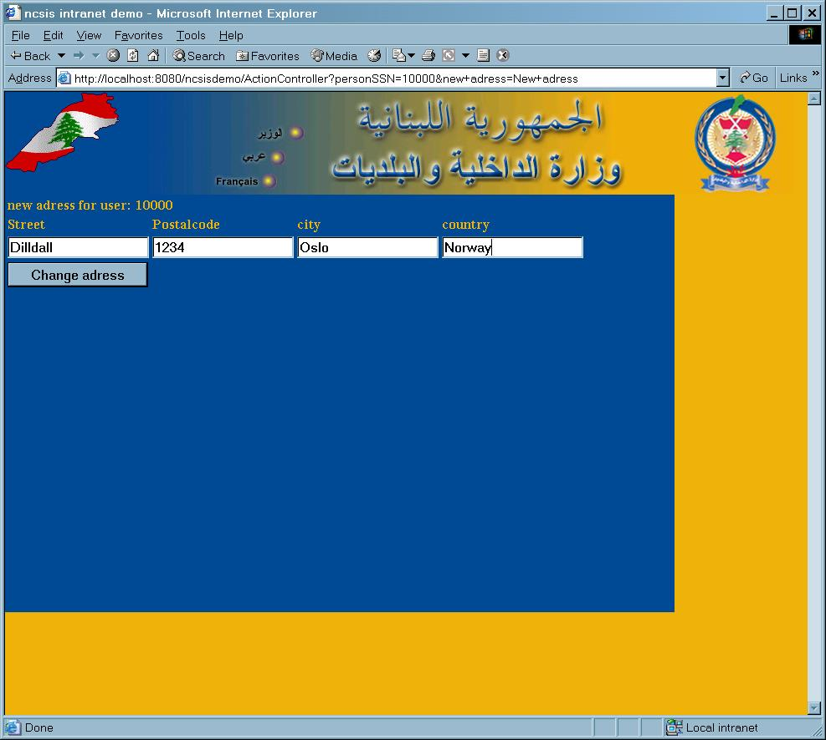

What type of event a local agency/authority will use depends on the rights defined in the NCSIS access control system on the actual person doing the registration. Also information about the citizen can be used to restrict at which geographic location or authority any registrations can occur. That is, citizens without proper identification must go to a specified authority to do the registration. Functions like this can be handled by the flexible access control system.

Verification.
A number of authorities inside and outside MOIM, need to check up citizen identity and inspect different information about the citizen. Depending on the number of lookups the different authorities need, the authorities can use different services to satisfy their need.
The general verification interface to the NCSIS is Web-based to simplify deployment and support. Different services will be provided. Examples of such services are:
- Show ID card information: which will return a representation of the information on the ID card based on the ID-card number entered.
- Verify Driving License
- Show children, which returns the registered children of a person holding a valid ID card.
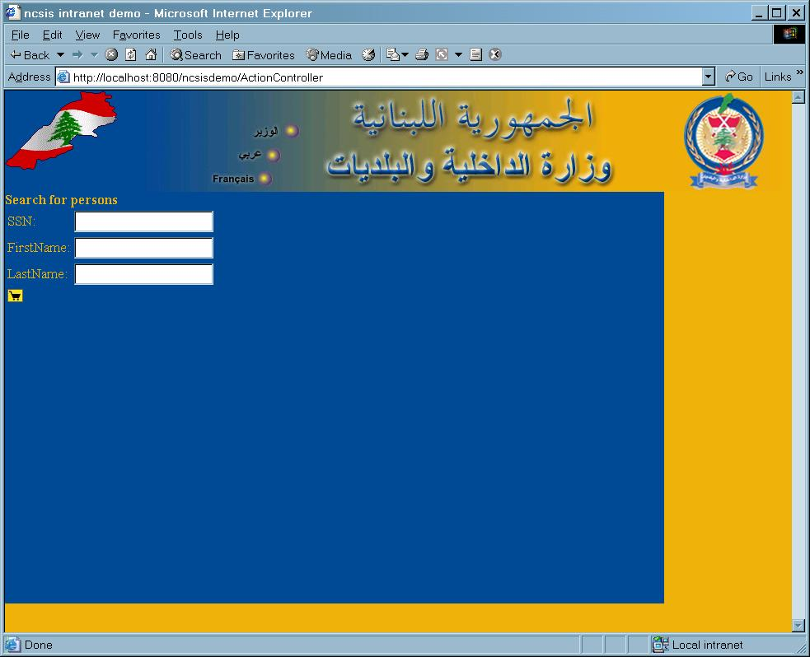
In a modern society, where a lot of information is gathered about each citizen it is important that the different authorities only can view information about the citizens applicable to their duties.
To control what information about a citizen an authority can view depends on the type of authority and the role of the authority person. The NCSIS Access control system provides this type of functionality, giving secure access to the data for the authorized persons and inhibiting access for all others.

Extraction
Some authorities or governmental agencies need larger extracts of the information in the NCSIS. An example is the need to provide a register of all citizens that shall receive Voting cards before an election. This is solved by services in the Integration block of the NCSIS. Depending on the authority receiving the extract there may be different rules applied to the extraction process to secure that the receiving authority does not see information in the NCSIS that is outside the authority’s area of responsibility. This type of rules are handled by a combination of how the extraction process is defined and which authority that can execute the extraction

An example of this filtering is that address information for voters with secret address should be empty when the extract is sent to the receiving authority.

Statistics

The NCSIS CSR facilitates excellent statistical functions. Some functions are direct extracts from the registered events in the system, like the number of births, deaths, marriages and divorces i.e these will be created online by the application. Other reports are more specialized and may include large and complicated queries on the data in the database. This type of reports will be provided by the Analysis tools and i.e. be made available to all interested authorities via the publishing system.

The NCSIS project will be responsible for the integration of the system and for the production of the first few reports together with MOIM experts as a part of the train-the-trainer concept. MOIM experts will implement further reports according to MOIM’s needs.

Auditing
The NCSIS facilitates the possibility to configure Audit on any function and data in the Civil State Register. The audit information will typically include information about function used e.g. address changed from xxx to yyy, user id. and time for change. This audit function makes it possible for the MOIM to track the use of NCSIS in detail and eventually prove any misuse of the NCSIS. E.g. Authentication & Access Control, Web services security and CSR will produce different logs with different views on the security. The Security Operation Center will analyze the audit logs, protect the operating NCSIS and report any incidence of misuse to the MOIM.

NCSIS Users
The NCSIS provides services for a number of different users. In the current context we have identified the following groups of users:
- Citizens
- Employees
- Agencies
- Other

The NCSIS architecture is scalable to a high number of web-based users and XML/web services interfaced systems. However, the proposed solution is designed to handle approximately 10000 web users and 20 XML/web services systems, which is regarded sufficient for the MOIM needs.
The NCSIS will be able to handle more users and systems simply by adding hardware and software.

Citizens
For the citizens, NCSIS provides services for civil state registration, which is important for all citizens in a modern society. The importance of a register handling births and deaths, marriages and divorces etc. is obvious, since this information affects the citizen’s rights and obligations towards the society. NCSIS also provides proof of identity with the ID-card provisioning, which again is a basis for a less bureaucratic approach regarding applications for passports, driving licenses and other situations where a proof of identity is needed.

Citizens can access the NCSIS in different ways. A couple of alternatives are shown in Figure 4, where the citizen either goes to the location of a local authority and communicates with a clerk that uses the NCSIS to provide the service. Alternatively, the citizen himself may access the service at the NCSIS directly for information and appliances. However, to enable the citizens to change own data (e.g. addresses) will require strong authentication (e.g. PKI and smart-card/ID-card and fingerprints). Strong authentication (PKI) of Citizens is optional in this proposal. This should be further discussed during the NCSIS envisioning phase.

The current proposed NCSIS covers access via Local authority to perform changes in the NCSIS registers
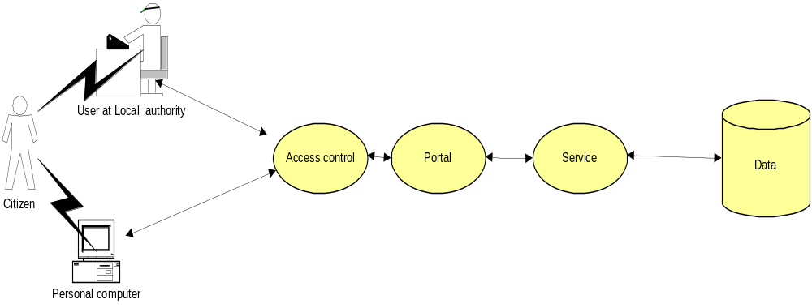
Figure 4 Citizen access

Employees
In the group of users called employees we include all employees of local and central authorities, agencies and organizations that will use the NCSIS to do their work, either for registration of citizen state information, checking citizens state information for different reasons or using the date in NCSIS for demographical, statistical or other purposes. Employees work with the system through different interfaces, depending on type of work they will do. The normal access is through a Web application over the intranet, this is exemplified in Figure 5. This web application presents information and provides services to the user through a portal according to a number of different criteria, like organizational relation, role, geographical location and other. The criteria is defined and controlled in the Access control system and used by the portal when presenting the web application to the users.

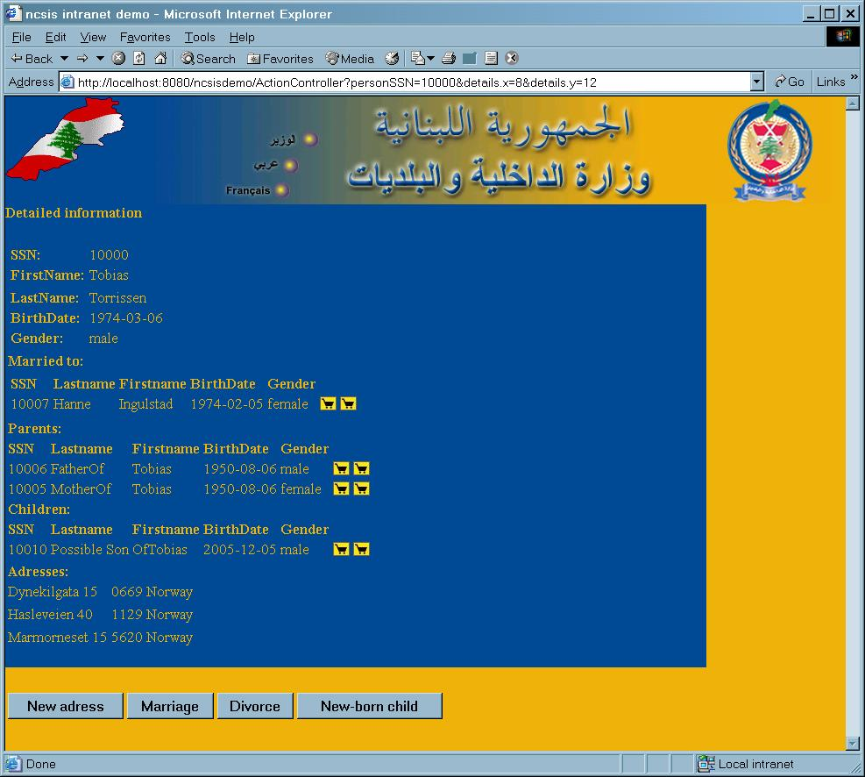
Figure 5 Web application example
The employees will be equipped with a password calculator for strong authentication. The intranet communication to the NCSIS is protected by VPN/HTTPS.
The current NCSIS proposal does not include possible additional costs for other user equipment like document scanners, fingerprint scanners etc. Possible needs for such additional features will be discussed during the envisioning phase of the project.

Agencies
In this context, agencies represents other authorities where the interaction with the NCSIS is not on the employee level, but where one has formal agreements on import of data to and export of data from the NCSIS. The interactions between the agencies and NCSIS can be by different means, like WEB services, direct database connections etc, but what information that will be available for import or export and in which form will be controlled by the Access control system based on the same type of criteria as for the employees. The access from other systems is also protected by web services security. For more information please refer to the security chapter.
The current NCSIS proposal does not include possible costs for other user equipment or alternative communication lines between the NCSIS center and the Agencies.

Other
Other users represent users that are not defined in the current version of the system, however the NCSIS has an open architecture and can be integrated with future systems.

NCSIS Channels
The NCSIS architecture is open for providing its services through any channel like telephone network, Internet, mobile/wireless, kiosks, TV or other.

The proposed NCSIS has included equipment and software for handing access via the telephone network (both analog and ISDN modems) and Internet. The proposed NCSIS is configured to handle access from Municipalities via telephone network (500 modems and 500 ISDN) and via Internet gateway (GW) (up to 20 other agencies) with a total of 10000 users.

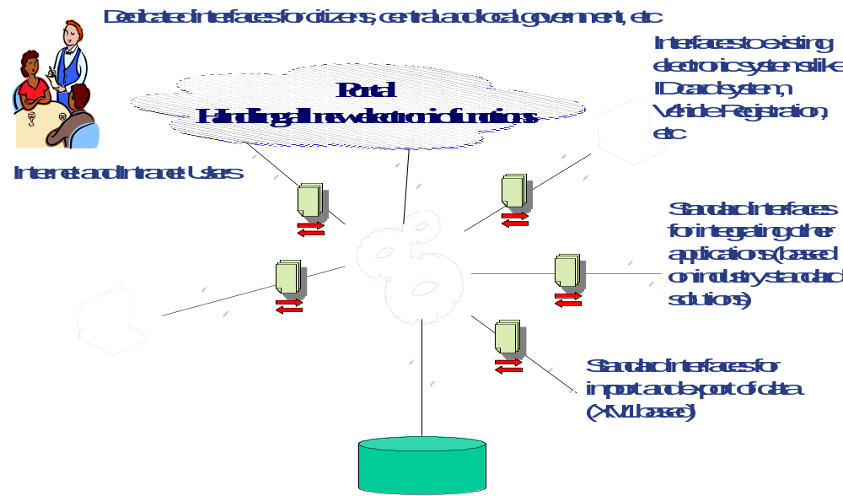

Figure 6 NCSIS Channels

NCSIS interface services

Portal
The Portal accommodates all enterprise portal requirements by facilitating the creation, customization, and management of multiple enterprise-class portals and portlets with rich user interfaces. It can deliver a single, unified portal framework for all e-government requirements by providing portal foundation services, personalization and interaction management, intelligent administration, and integration services.
- Faster time-to-deployment; reduced development time
- Lower maintenance operational cost
- Leverages a single, unified architecture for all portal initiatives
- Leverages legacy systems investment through standards-based XML integration
- Increases performance and scalability with critical content rule and property caching

The portal facilitates all channels including terminals in mobile network, WLAN or Internet.

Integration layer
The NCSIS Integration layer features robust, standards-based application integration functionality that simplifies the integration of new J2EE-based applications within and across existing systems and applications such as enterprise resource planning (ERP) and supply chain management (SCM) packages. It’s designed to speed time-to-value, reduce IT costs, and future-proof operations by supporting easy upgrades and enhancements.
- Standards-based, “build-to-integrate” JSEE Connector Architecture with a number commercial connectors to e.g. databases and industrial standard applications
- Easy-to-use integration framework empowers staff to design the integration solution
- Eliminates need for hard-coded, proprietary adapters to connect applications
- A holistic solution for building, hosting, integrating, and extending mission-critical applications
- Manages complex processes across organizations and among disparate systems

The NCSIS integration layer will integrate the new Civil State Register with the existing MOIM systems :
- CNI-1 ID-card and archive system
- Voting System
- Passport system
- Driving license system
- Vehicles Registration System
- Central Adm. Of Statistics

In addition the integration layer will implement a standard generic interface to the NCSIS based on XML/web services giving existing and future external systems the possibility to exchange information with NCSIS. Access to services and parameters are on a need-to-know basis. Typical services (to be decided in the envisioning phase) are:
- Get Civil status information on person x
- Get Civil status information of all persons
- Get Civil status information of all persons in municipal x or region x
- Change voting status on person x
- Change passport status
- Change Driving license status
- Get voting list from municipal x

NCSIS platform services

Application Server

The application Server supports all Java technology services, including Enterprise JavaBeans, Java technology-enabled database access services, and standard Internet security protocols in an application platform that provides unparalleled performance and scalability. What’s more, as part of its standard product features, the Server can incorporate integration with legacy systems and other J2EE application servers. To earn Common Operating Environment (COE) certification—the de facto standard framework for strategic computing systems—the Server met or exceeded hundreds of technical requirements covering encryption, interoperability, performance, reliability, and security.
- Designed to integrate and co-exist with Microsoft-based solutions
- Decreases the need for cross-education and re-training of personnel
- Easy integration with back-end systems
- Open architecture supporting plug-ins to third-party security solutions
- Integrated with standard Internet and XML protocols

Other tools
The NCSIS basic tools also includes the following elements:
- Reliable, easily managed, high performance, and secure web server for static HTTP request.
- Scaleable high performance database system
- Proxy server for authentication and redirection
- Security server providing authentication services

Security
The NCSIS security has a balanced and integrated security architecture including Single Sign-On features, Authentication and Authorization system, Firewalls, Intrusion Detection System, XML web services security, PKI (optional), application security and a Security Operation Center.

The NCSIS access control system denies access for un-authorized users and systems. The NCSIS authentication system assigns the authorized users to roles. The applications then give access to functions and information based on the role. NCSIS will seek to implement a Single Sign-On solution for all services. This is, however, dependent on the specific selection of off-the-shelf applications used to implement different services.

The NCSIS Security concept will enable MOIM Security manager to monitor, control, restrict and audit both user and system access to data and applications in a detailed manner.

The NCSIS security level is at the same level used in modern banking and financial industry

Security Architecture
The security architecture is based on a few architectural principles to withstand attacks and to minimize the consequences of a penetration.
- All communication between workers in the municipalities and the central cite is strongly encrypted using TLS/SSL.
- All access to applications is done via web browser reducing the probability for end user malware infections to spread into the application.
- All users are authenticated on a separate proxy server before access is granted to the application itself.
- The authentication proxy, the application server and the test servers and AAA servers all reside in different security zones separated with firewalls.
- All communication with the central system is monitored by IDS (Intrusion Detection System).

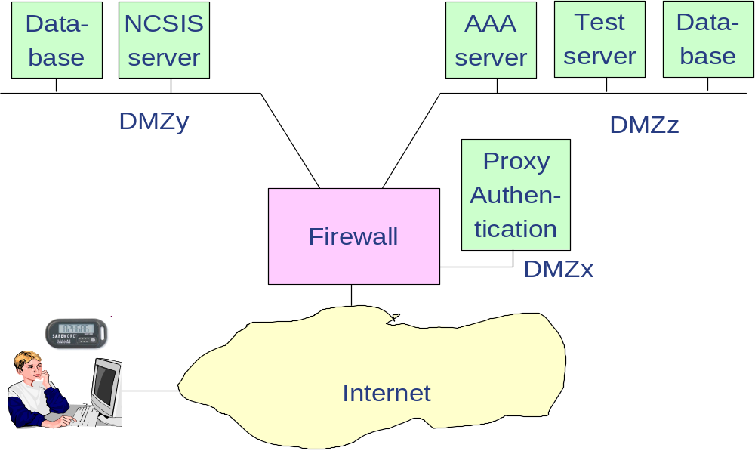
Figure 7: Brief security network diagram

Most of these principles are illustrated in Figure 7. The user will have to access the proxy server and authenticate before access will be granted to the NCSIS server. The authentication process itself is done with the token towards the proxy, which communicates to the AAA server to verify the credentials of the user. In the zone where the proxy server is located there are also IDS sensors. The ID sensors monitor all activity on the network and on the proxy itself and reports to a central server for further analysis and reporting. More details are depicted in Figure 8.

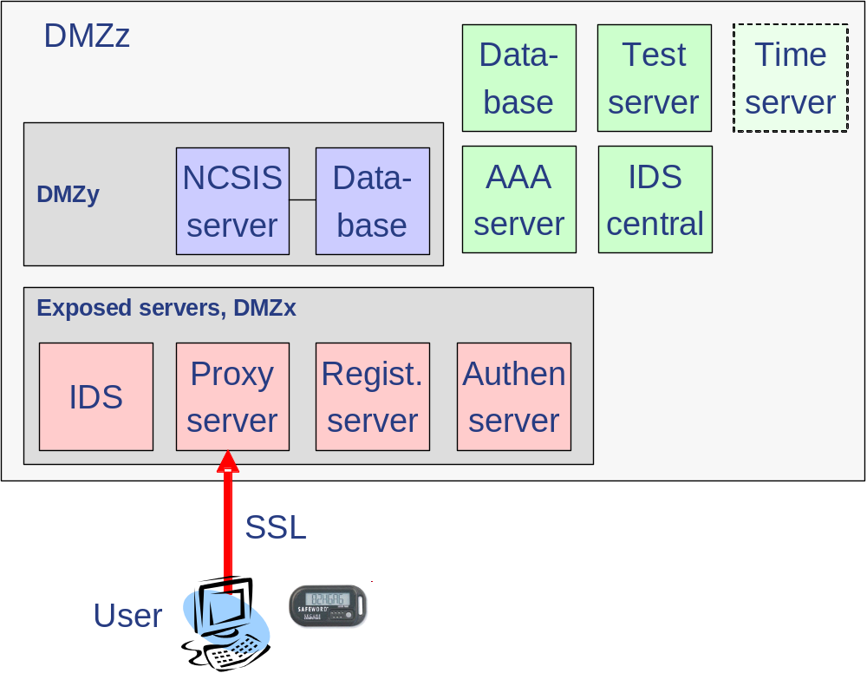
Figure 8: Security system components
In the figure above, we also see the IDS central and the registration server that enables user self-registration via web interface. The proxy server, authentication server, enrollment server and the AAA server are all SafeWord Premier Access from Secure Computing. An eventual time stamping server is optional for time stamping transactions for archiving purposes.
The proxy server will also work together with the application server to perform access control and personalization. The proxy server will when forwarding http requests insert extra http headers to signal to the application server the role and access rights of the user and other preferences like language etc.

Integration - XML/Web Services Security
The NCSIS is designed with an open integration architecture based on XML/Web Services. Governmental Agencies internal or external to MOIM will integrate via standardized XML/web services. In the future, some services can be offered to e.g. banks and even private persons. The security architecture will protect the communication between the NCSIS and the other system with VPN. The NCSIS must be able to deny or limit access to services, parameters and data in a flexible and secure manner. E.g. one service is “Extract Information with parameters (age x to y, sex, area)” and will return with a full dataset of information.

The NCSIS includes an XML/web security server: a platform for securing XML and Web Services communications throughout the NCSIS/Government. It can be deployed in front of XML systems as an XML Gateway (sometimes called an "XML Firewall"), or it can distribute XML security enforcement points across the network/servers. To address the security challenges posed by XML-based communications, an
XML security server must deliver best practice security techniques using open standards, and must integrate with existing corporate security infrastructure.

The XML security server process XML data according to the following key security requirements:

- Authentication. Authenticate a user/agencies using session-based authentication, or from security tokens enclosed in SOAP messages using WS-Security. The identity of the user is verified using local directories, PKI (optional), or global trust services.
- Authorization. Perform policy-based authorization according to identity rules, then communicate authorization and attribute information with other security infrastructure using SAML.
- Content Checking. Analyze the structure and content of XML requests using XML formatting standards to ensure that inappropriate or harmful data does not reach XML systems.
- Integrity. Examine the integrity of a message to ensure it has not been amended or tampered with whilst in transit.
- Routing. Perform SOAP routing in order to pass a secured message to the designated Web Service either using routing information within the SOAP message, or pre-configured routing rules.
- Audit. XML traffic is tracked and security events identified. The XML security server is configurable to provide real time activity monitoring and to generate reports based on archived transaction records.
- Alerting. Provide configurable alerting facilities, based on the centralized logs, which are used to notify relevant parties of suspected security attacks. For alerting purposes the XML security server interfaces both with the Intrusion Detection Systems and the OPSEC-compliant firewalls.

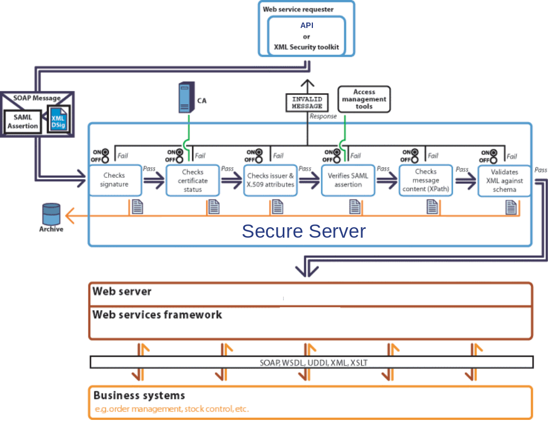

Single Sign-On
NCSIS Single Sign-On (SSO) solutions provide easy access to all applications and Web sites by replacing all those hard-to-remember user IDs and passwords with a single authentication. Users authenticate once, and the SSO solution does the rest.
NCSIS SSO is basically a client only SSO solution making it very easy to deploy. It works with nearly any logon service and integrates with password tokens and PKI solutions. An SSO service is a service where the user logs on to the service, which will further, transparently for the user, log him on to any system he has the right to access. Even though it is a client only SSO solution it works well with infrastructure services like LDAP, PKI, AAA etc. These services can be used to log on to the SSO service in a secure way. The means used by the SSO service to log the user on to the final application depends on the capabilities of the application. Logging on to a “password only” application, the SSO service will log on using password only. It will recognize that passwords expire and automatically and transparently for the user generate new passwords according to defined password policies. An SSO service will greatly reduce the workload of user management.

Other Security elements
NCSIS will also utilize firewall and VLAN technology for securing the NCSIS operation.

IDS

Security Operations Center
The Security Operating Center is the core of all NCSIS security services, majoring on vigilance and care for NCSIS networks and systems.

First to third line Engineers react to security incidents and ensure their correct and timely handling. The Internet Security Analysts perform continuous analysis to evaluate and ensure that Monitoring and Alert profiles are established according to the latest threats and exploits.

The SOC carries out monitoring and analysis of Internet protocol traffic and data. This allows a thorough understanding of normal traffic patterns, to be able to provide the best possible Intrusion Detection and Incident Monitoring profiles.

The data is collected through the specialized Sensors and Agents in NCSIS networks and servers, according to the established Incident Monitoring profile.

The SOC may also provide Incident Handling to help rectify faults and attack situations either due to external perpetrators, or operational errors.

The alert and response time is agreed upon and may be changed if operational and organizational requirements alter, as a result of increased exposure. This may be caused by anything from unstable situation to releases of new exploits or hacking tools.

The NCSIS Security Operations Center is on the alert to give the NCSIS the right level of monitoring and operational security to match their needs, including 24x7 hours all year round capabilities.

Sensors and Agents

The NCSIS can be supplied with a wide range of sensors and agents to improve Internet Security. Some are listed below:
- Host based IDS Sensor
- Signatures Based Attack Sensor
- Anomaly Based Attack Detection Sensor
- IP Network and Services Metrics Sensor
- Web Defacement Agent
- Denial of Service Agent
- Abusive Remote Login Agent
- Abusive File Transfer Agent
- Usenet Abuse Agent
- E-mail Abuse Agent
- Brute Force Prevention Agent

The detailed design and selection must be done in cooperation with MOIM security experts.

Intrusion Detection System (IDS)
The NCSIS Intrusion Detection System (IDS) will install two network based IDS (NIDS), two host based IDS (HIDS) and a central management station. It will also consist of planning and development of a Security Operations Center (SOC), an Incident Response Team, and training of people and especially IDS analysts. Tuning of the IDS system to reduce false alarms is also included. Training of analysts will be done in two phases, one phase in Norway and one phase on site in the SOC. The purpose is to enable the SOC to conduct a 24/7 security monitoring and operation.

Platform Security
The NCSIS application Server/portal provides a comprehensive security architecture encompassing access control, cryptography-based privacy , and user authentication. It also utilizes user- and group-level Access Control Lists (ACLs), Realms, Secure Sockets Layer (SSL), X-509 Digital Certificates, and other standards-based security measures such as LDAP and PKI. When combined, these security features can identify and track individuals accessing any service.

Public Key Infrastructure (PKI) (Optional)
The NCSIS project will optionally include a national PKI in the proposal. PKI is not considered necessary in these phases of the NCSIS project. The number of NCSIS users is currently limited (10000). The NCSIS can however be realized with a limited (not nation wide) NCSIS PKI within the program. The NCSIS PKI can be included in the NCSIS during the NCSIS Envisioning Phase if the NCSIS concept should change to open for a large number of Lebanese citizens to perform changes in the NCSIS based on a strong identification or MOIM of other reasons will implement a NCSIS PKI.

Initial NCSIS PKI

Citizens (strongly authenticated) can use the Initial NCSIS PKI to e.g. change addresses in the Civil State Register via Internet or service stations. The citizens can be authenticated with a zero footprint solution and one time password supplied via mobile telephone SMS.

This PKI proposal is describing an initial PKI infrastructure and not any nationwide PKI. The proposal is based on CA (Certificate Authority) from Cryptomathic A/S (Denmark) and a PKI client solution named Signer from the same company. The CA is a general CA product that issues certificates to certify the binding between a user and his public key though a PKI certificate. A Hardware Security Module (HSM) protects the CA’s private key used to generate certificates. The user’s private key (corresponding to his certificate) is kept inside a HSM in the Signer server. The key will never leave the HSM in clear and all cryptographic computations takes place inside the HSM. The certificates are stored in a LDAP directory server.

On the client side the user has two options: either a zero footprint solution where the client is an applet, or a CSP (Cryptographic Service Provider), which is installed in the kernel of the OS. Both types of clients talk to the Signer server to have the cryptographic operations with the user’s private key performed by the HSM. The user has to authenticate himself, via the client; to the server using one-time passwords, either generated by a token, or sent to him via SMS. The applet client can do authentication and digital signature in the web channel. The CSP client interfaces to any client like, browser, VPN, e-mail, office application etc. just like the CSP function in Windows does.

The Cryptomathic Signer system is currently undergoing evaluation against Common Criteria EAL 4+ SSCD Protection Profile. If it passes it will be certified for qualified signatures according to the European standards. The requirement is that the CA meets the requirements for issuing qualified certificates.

The servers can be clustered for extra reliability. This configuration is scaled to be an internal installation. It can however be expanded to a fully national PKI infrastructure by scaling up servers and licenses and adding redundancy. A fully national PKI infrastructure should be built according to the rules and regulations of the EC. Quite some work is going on to harmonize these regulations on an international level to achieve fully globally recognized PKI regulations. To withstand catastrophic events it should be geographically dispersed.

Time-stamping and archiving service

The PKI infrastructure can be augmented with a Time-stamping and archiving service. A TSA (Time Stamping Authority) is a server that can sign timestamps of document hashes. This is part of a notary infrastructure to provide a non-repudiation service, which is crucial in deploying e-commerce. A TSA service relies on correct clocks synchronized to Coordinated Universal Time (UTC). There are considerable ongoing international activities to achieve internationally recognized rules for such a service. The service will provide proof of time and correctness for documents. The standard for communicating with the service is defined in RFC 3161. The draft document Policy Requirements for Time-Stamping Authorities sets out the internationally agreed requirements for the service.

The service should be complemented with an archiving service to provide long time archiving of time-stamped documents. International work on Trusted Archive Authority (TAA) and Trusted Archive Protocol (TAP) still has some way to go before international agreement is reached. On the web there are overviews of EU and IETF (Internet Engineering Task Force) PKI initiatives.

The proposed configuration is intended for an internal service and is not scaled to a national infrastructure level. The configuration can be clustered for performance and to withstand catastrophic events it should be geographically dispersed.

NCSIS Advanced services

Publishing
The NCSIS Publishing tool enables NCSIS to aggregate a common view on content from various sources and manage and deliver all content in multiple formats and languages to multiple websites, channels, online applications and print.

The NCSIS Content Manager is at the heart of NCSIS Publishing. It provides an enterprise platform that enables large organizations to create, manage, distribute and deliver the content (documents presentations, work plans, spreadsheets, etc.) to different communication platforms.

All NCSIS Content Manager functionality can be accessed via an easy-to-use graphical interface running on a standard Internet browser.

Typical features of a publishing / Content Management system includes:
- A role based security model for collaboration
- Versioning and Rollback
- Library services
- Workflow
- Globalization and localization
- Website and Publishing management
- Blueprint management
- Content archiving

The NCSIS Content Distributor can distribute content to any delivery platform independent of their location. Content distribution is initiated via the graphical user interface, where users can publish selected content to selected delivery platforms. The Distributor allows you to choose static (pre-distribution), dynamic (at content request time) or any preferred combination for your content assembly strategy.

The NCSIS project is responsible for establishing the publishing functions with processes, structure and a set of templates for information flow. The project is also responsible for the training of MOIM instructors. The MOIM will be responsible for the information content, publication, distribution and training of the MOIM editors.

Analysis
The NCSIS is supplied with a top-of-breed analysis tool to perform analysis to support governmental planning based on the NCSIS data and other data sources.

The NCSIS Analysis application provides tools essential for mastering the four data-driven tasks common to virtually any application: data access, management, analysis and presentation. All tools are within a powerful applications development environment.

Data Access
NCSIS Analysis application brings out the facts hidden in the files. Read data in any format, from any kind of file, including variable-length records, binary files, free-formatted data – even, to some extent, files with messy or missing data.

The special data access interfaces of the NCSIS Analysis application enables NCSIS to connect to leading database management systems internal or external to NCSIS. For covering the needs identified so far, the NCSIS project will connect the Analysis application to the NCSIS database, any other needs must be discussed during the envisioning phase of the project.

Data Management
Once the analyst has put the data into the NCSIS Analysis application, the analyst can manipulate it any way he chooses. Powerful tools help the analyst to maximize data processing efficiency, with facilities for sub setting and merging a wide range of data sources.

NCSIS Analysis supports Structured Query Language (SQL), the ANSI-standard and widely used language that allows you to create, retrieve and update database information. Also included is the SQL Query Window, an interface that provides the ability to build queries through a point-and-click process. Build, save and run queries without being familiar with SQL.

Data Analysis
NCSIS Analysis provides powerful data analysis tools. Create analyses to concisely summarize the data, such as frequency counts and cross-tabulation tables. The analyst can use NCSIS Analysis application to compute a variety of descriptive statistics, including the mean, sum, variance, standard deviation and more. Compute correlations and other measures of association, as well as multi-way cross-tabulations and inferential statistics.

NCSIS Analysis can extend the analytical capabilities with the addition of specialized components for planning, forecasting, quality improvement, project management, decision support and more.

Data Presentation
NCSIS Analysis can be used to produce reports ranging from a simple listing of a data set to customized reports of complex relationships. Many reports require only a few statements and no programming at all.

Applications Development
NCSIS Analysis provides the users with a flexible and productive programming environment. There's a command-driven interface especially for power users, systems analysts, application developers, experts on MIS (Management Information Systems) and Information Center staff.

From this interactive windowing environment, applications can be quickly developed with easy-to-use commands, a fully customizable tool bar and a dynamic menu bar. Further customization is possible to enable the user to create a highly productive environment for developing different applications.

The NCSIS project will establish the framework for using the tool in cooperation with MOIM experts in the envisioning phases and produce templates for most common analyses. The project will train MOIM experts to perform and build new analyses based on the tool.

Rule engine and workflow
Regulations, policies and rules are changing due to political decisions and technological changes. Therefore the NCSIS incorporate an automatic rule engine for capturing, managing, and automating business requirements, regulations, policies and other knowledge.

Using the Rule Engine, business professionals can dictate their knowledge (including business policies, practices, regulations, diagnostics, and other customer service knowledge) and especially rules in plain English sentences via a graphical interface supporting several methods of describing the rules;
- Importing from text
- Typing (with automatic word completion)
- Selecting from word lists

The Rule Engine provides real-time guidance in what can be said and understood based on the information systems models. The Rule engine ensures that your sentences are grammatically correct and unambiguous.

The Rule Engine together with the Workflow Engine will constitute the core functionality in NCSIS automatic evaluation of input to the system. Not all input control can be done automatically, but most of the rules for civil state information can be handled and validated automatically.

Once the implementation of the vocabulary used by a set of statements is specified, the Rule Engine can generate the business logic that automates decisions. The representation of statements stored by the Rule Engine is language-independent.

The rules in the workflow will depict the functionality of the NCSIS. Based on the implemented business vocabulary the MOIM professionals can modify most of the behavior of the NCSIS in line with new regulations or rules without involving the NCSIS development resources.

E.g. the NCSIS workflow builds its behavior on the following rule: “A voting card shall be produced to all Lebanese Citizens over 21 year”. Example scenario: The state of Lebanon changes the election law in 2004 and allows Lebanese Citizens over 18 years to vote. MOIM professionals can change the behavior of the NCSIS system by simply changing the rule to: “A voting card shall be produced to all Lebanese Citizens over 18 year”.

The NCSIS project will together with MOIM experts develop and integrate the vocabulary and rules used by the NCSIS and train MOIM experts to perform changes in the NCSIS based on vocabulary and rules.

The NCSIS Workflow Management structures and automates business processes. By linking people and IT applications together, it ensures consistent, effective implementation of work processes across the organization and geographical locations. At the same time, it provides information about the progress of each case, an up-to-date description of the work processes in the enterprise, and functions for measuring efficiency.

Document Management
Simple and rapid access to mission-critical documents is a success criterion for an effective business. The documents contain a wealth of knowledge. It is therefore important to ensure that they are stored in a structured manner, and that they are accessible anywhere at any time, regardless of the storage location.

The Document Management module takes care of all types of documents - whether they have arrived on paper, by e-mail or have been produced using MS Office or other tools. In addition, it offers a number of standard solutions for both public- and private-sector business which link document management together with the Workflow, the Portal and the Content Management System. This makes the electronic archive a highly effective productivity tool.

Key features include:
- Archival of all types of documents
- Integrated document production
- Seamless connection to MS Office
- Excellent search functionality
- Advanced access control
- Revision management
- Scanning
- Solutions for public-sector administrative procedures (NOARK 4 [the Norwegian standard for archival of electronic documents in State organizations], etc.)
- Solutions for project documentation and technical documentation

The NCSIS project will together with MOIM experts define and implement the infrastructure of the Document Management system and integrate the system in NCSIS. The project will train the MOIM trainers who will implement the system in the MOIM organization.

Demographic service
The NCSIS project will enable MOIM to implement a range of Demographic services based on the supplied analysis tools.
The project itself will implement a few services, with the main intention to prove the integration between the analysis tool and the CSR and to educate MOIM trainers to implement new services based on MOIM needs. The services to be implemented must be discussed during the envisioning phases.

A typical service is to predict the age and sex composition in the Lebanese Population in the future based on demographic indicators, this is very useful for planning purposes, e.g. how many children are likely to start at school in Anjar in 2010 (do we need to build a new school?), etc.

Another example of use of Demographic Services can be to predict the changes in the Lebanese population for the years to come. Based on the information in the NCSIS it will be possible to analyze and predict the future age and sex composition in the Lebanese Population in 2000 and 2025. The figures below are examples of how such analysis can be presented. Such analysis can also be done on local or regional levels to give input for planning to local and regional authorities.

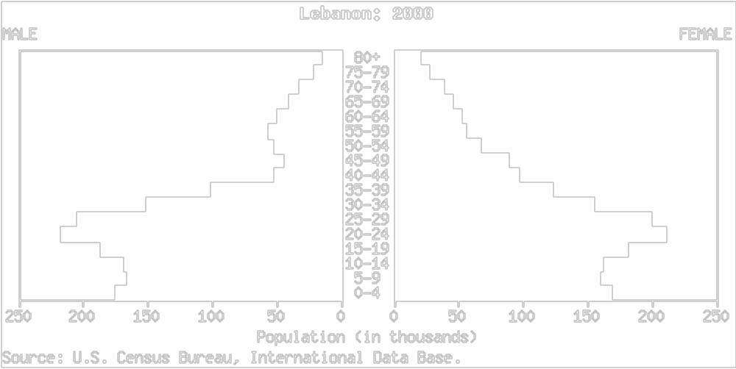

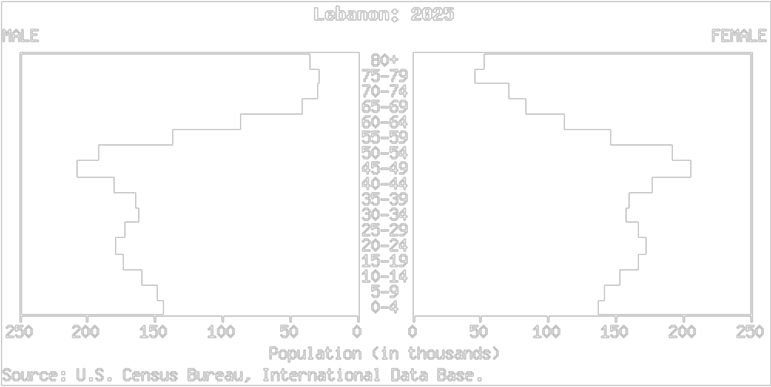

Figure 6 & 9 Age and sex composition in 2000 and 2025

Digital geographical information systems
The NCSIS utilizes a modern solution to manage digital geographical information. Fundamental in this solution is a Map Server capable of handling maps of the real world and additional information such as which street or building a person lives in. The structure of this tool is described in Figure 10 Information layers.

The Map server is a core component in a modern digital geographical asset management system. It is the gateway that facilitates managing spatial data in a database management system. Further the Map server enables the user to export and import geographic information using formats developed by international organizations like ISO and OGC.


Figure 10 Information layers
Geographic information can be accessed using browser based applications, or trough other GUI based applications. The screen in Figure 11 Detailed map shows the user interface to view a neighborhood with all persons listed and their addresses located on the map. This application gives the user a choice to find persons through an area search on a map, or by searching on other properties like name, age or social security number.
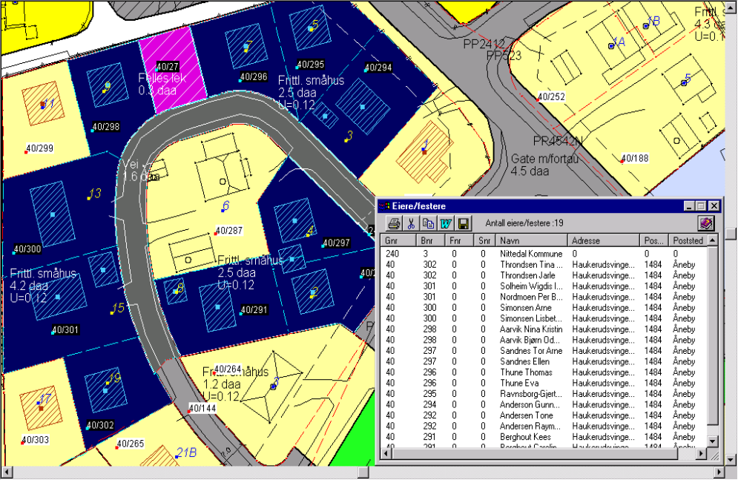
Figure 11 Detailed map

The NCSIS project will define the use of a GIS system together with MOIM experts and integrate the system into NCSIS. The project will also import available digital maps according to international standards and train the MOIM experts to utilize the system. The digital maps must be supplied by the Lebanese Authorities, and MOIM will populate the GIS system with the necessary information on people and addresses.

MOIM operation
MOIM operation interface is a simplified, integrated framework that enables different MOIM experts to administrate and use the:
- Security system for MOIM Security officers
  - User administration
  - Web services security (external system authorization)
- Workshop where e.g. MOIM business rule experts, analyst, editors and authors use
  - Workflow/rule engine to adapt the NCSIS to e.g. new laws
  - Publishing system
  - Content management system
  - Geographical Information system
  - Demographic system

User administration
The NCSIS will have a large number of users. First of all, the system will have users at the municipal and regional level doing the actual registration of changes in the civil state etc. Beside these, other users in other authorities inside and outside the MOIM, will use the NCSIS for registration and verification of civil state information or for other necessary purposes. If all these users were to be managed from a central office it would create a heavy workload on the central organization and give little flexibility in the daily operation of the system. The NCSIS allows user management to be delegated from the central system to regional authorities or other directorates or ministries. This means that the GDCS authorize personnel in the different applicable organizations that again can authorize personnel in their own organizational structure. The figure below depicts this situation.

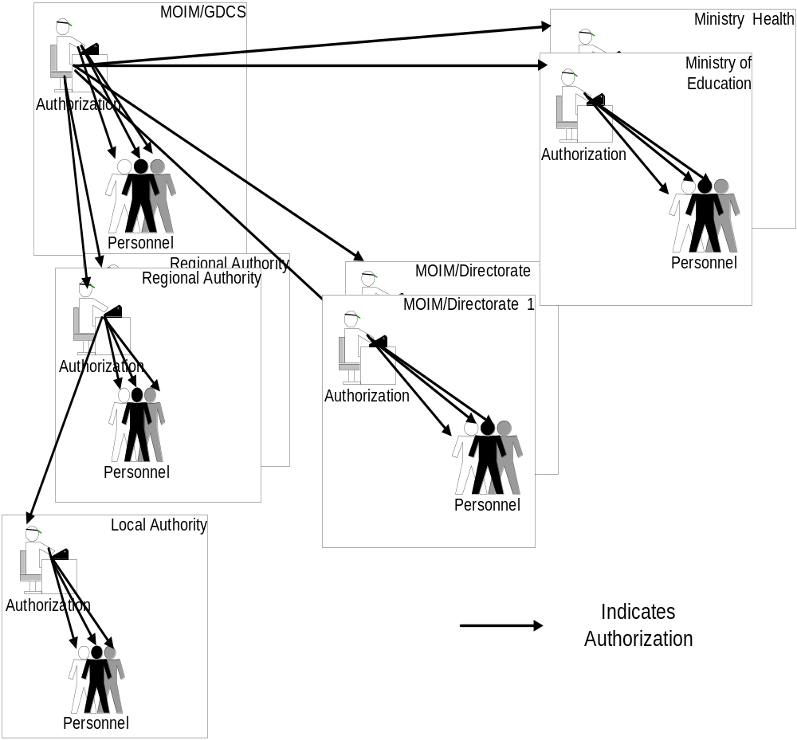

An authority with delegated privileges cannot give anybody more rights than have been delegated. The NCSIS also support the restriction of rights based on regional and municipal properties. This means that one can restrict personnel to only have registration or verification rights for local citizens. There are functions in the user management system to revoke any delegated rights from any level of the organization from the NCSIS central user management.

Also the system provides tracking of the user access and can report any attempts to misuse the delegated rights.

System Management

System administration
The NCSIS System Management is a total concept to managing the network, IT and Service Infrastructure.

Operations Management
Operations Management is an advanced availability management solution for keeping distributed, multi-vendor computing environments up and running. It provides a fully integrated management solution for systems, networks, applications, and databases. Operations Management is a distributed client/server software application, whereby the server acts as a Central Management Console and the clients act as Intelligent Agents. From the Central Management System, you can take full control of the distributed IT resources across the enterprise, identifying potential problems before they occur and resolving them before end-users have been affected. The powerful Intelligent Agents can be configured to solve problems without interacting with the Central Management System, a major step towards self-managing systems.

ECS designer
The Event Correlation Services (ECS) Designer is a powerful tool that offers sophisticated capabilities to create customised rules for specific event correlation requirements. The ECS Designer GUI makes the complex process of event correlation design intuitive and user-friendly.

Navigator
Navigator's graphical Application Service Views can capture the elements of a complex end-to-end service environment, such as network elements, computer systems, databases and the applications themselves, and then display their interdependencies in an easy-to-understand manner. IT staff can then look at the complex dependencies between these managed elements and interpret lower-level data in terms of importance to the higher-level service.

Reporter
A flexible and easy-to-use web based management reporting solution for the distributed IT environment.

Service Desk
Offers comprehensive service management capabilities so support organisations can implement proven processes into a single, seamless workflow. Through this unique level of integration, the entire workflow process is managed, allowing the service desk to operate preventatively, with critical information at their fingertips.
Service Desk delivers an integrated approach to support the following processes:
- Configuration management
- Call management
- Incident management
- Problem management
- Change management
- Work management
- Service level management
- Network management

Performance Management
Performance is comprised of the Performance Manager and Performance Agent. Together, they provide a single interface for centrally monitoring, analysing, and forecasting resource utilisation for distributed and multi-vendor environments. Whether your environment consists of a single system or a large network of systems, the fundamental goal is the same — to offer the best possible level of service in a cost-effective manner.

Network Node Manager
Network Node Manager (NNM) is a comprehensive network management solution. It provides network views in an intuitive graphical format. NNM discovers network devices and provides a map to illustrate the structure of the network and the status of devices and segments. When a major device fails, the event correlation engine evaluates the event stream to pinpoint the root cause of the failure. Other capabilities help network administrators prevent problems by identifying potential trouble spots before a failure occurs.

Backup and Restore management
The Backup and Restore management (BRM) provides the most reliable, high-performance data protection for heterogeneous and Windows-based computing environments. Specifically tailored for ease of use and automated operations, BRM offers comprehensive backup and restore management for a variety of configurations-from a single server to a distributed, multi-site enterprise.

QoS Management
QoS Management helps you ensure the performance of IP services across the network through automated policy-based configuration. You can control quality of service (QoS) through the deployment of policies defined on the basis of application, protocol, source/destination address, time of day, and so on. QoS management enables you to make optimal use of existing network resources and currently provisioned bandwidth. With QoS management, you can:

- Assign high priority to selected applications to assure them of the required bandwidth.
- Limit the bandwidth consumed by selected applications (FTP, for example), by specific URLs, or by Internet traffic in general.
- Develop prioritised levels of service and assign traffic to these levels by application type, source, and/or destination.
- Proactively monitor customer connectivity and will serve as the repository for customer-reported operational problems.

System management storing and monitoring
All information monitored and pro-actively managed by the System management can be stored in the System manager database (Oracle). Selected events from this database can be forwarded to a trouble ticket system such as Service Desk or other trouble ticket systems. Reporting tools can generate reports in order to get a better understanding of the status of the service levels.

The System Management offers a central GUI where all relevant information will be presented to the operational staff; this interface can be implemented in a way that the operational staffs gets only the relevant information depending on their user profile.

IT infrastructure

The following figures exemplify the IT infrastructure for NCSIS. The overall infrastructure is shown in Error: Reference source not found
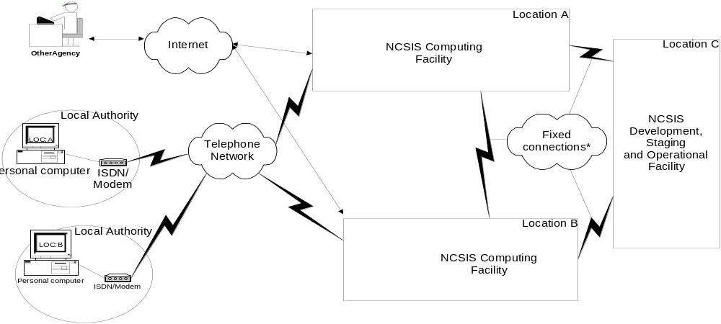
Figure 12 overall infrastructures

The figure shows the overall infrastructure consists of two NCSIS computing facilities, marked A and B, containing identical systems that provides the NCSIS functionality. The systems are duplicated to satisfy the requirements for availability and resilience. The duplication also makes it possible to use one of the facilities for acceptance of new functionality, while the other facility handles the normal operation. Depending on the overall requirements, these facilities can be located at different places, e.g. Beirut and Tripoli, on separate floors in the same buildings or in the same room. Beside the computing facilities, there is a facility where development of functionality, Publishing of information and operation of the system is done. This facility, the NCSIS development, staging and operational facility can be co-located with one of the computing facilities or at a totally different place. At the left of the figure, the municipal users and other authorities are indicated.

All users in the municipalities connect to the NCSIS facilities through modem/ISDN connections. The local PC is configured with the phone numbers of both location A and B. Half of the users have location A as first choice, the other half have location B as first choice. If, for some reason, they cannot connect to the location that is the first choice, the PC will automatically connect to the other location. In this manner the system automatically handles situations where one of the facilities is off-line, either because of problems or support, and it also provides an easy solution for load sharing. Depending on the available infrastructure in the different municipalities or cities, some local users may also connect to the system through Internet.
Other MOIM agencies or other authorities connect to the NCSIS computing facilities through Internet using Virtual Private Network (VPN) to provide security. The figure below shows a more detailed view of the computing facilities. Each facility has an access to Internet for connection to other MOIM agencies or other authorities. The actual implementation of this access depends on the available infrastructure. In the figure below this access is indicated with the Cisco 6200 router.To handle access from the municipal user over modem/ISDN, the system has an access router that can handle ISDN or modem access. The Cisco 5200 indicates this.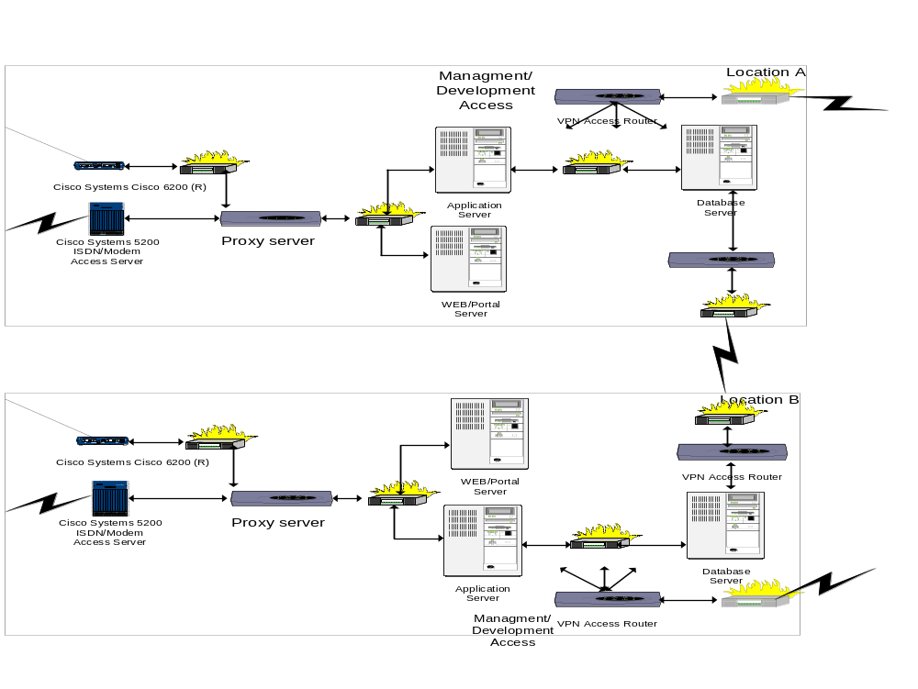
Figure 13 NCSIS computing facilities
Behind the access routers, all requests from external users arrive at the proxy server. The proxy server resides behind a firewall and handles authentication of users, verification of requests and routing of the requests to the correct server, either the Web/Portal server or the application server. The Web server handles static non-personalized information, while the Portal server handles personalized information. The portal server forwards requests to the application server both when requesting information from the registers in NCSIS and when submitting new registrations or changes to the registers in NCSIS. The application server is the equipment that contains the business logic of the system and receives requests either from the portal server for normal user access or directly from the proxy server for external extraction or insertion requests. It is only the application server that accesses the registers in NCSIS. The registers in NCSIS are stored in the database server that is in its own security zone behind a firewall. The database server also includes the storage and logging system, which is not shown for simplicity. The database server in each facility has a VPN connection over fixed leased lines to the other site that is used for synchronization of the databases. The capacity of this connection will be decided during the detailed design.All firewalls indicated on the figure can be part of the same firewall equipment. Each NCSIS computing facility also has a connection to the NCSIS development, staging and operation facility. This connection is also a VPN connection over fixed leased lines. The NCSIS development, staging and operation facility is shown in the figure below.

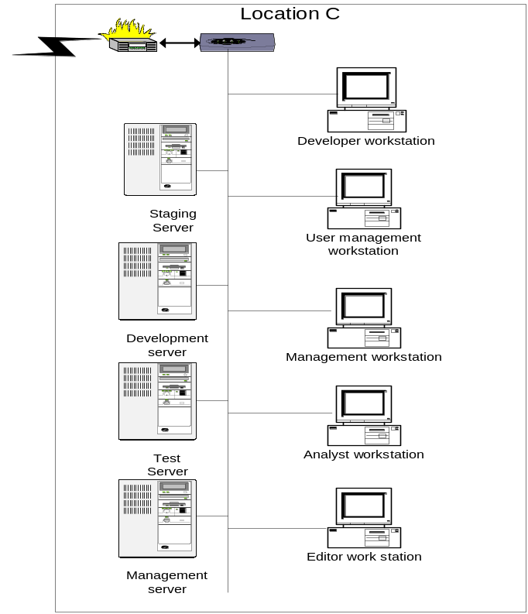
Figure 14 NCSIS Development, staging and operational facility

Quality and Processes
............................................ has its own Quality framework based on Tick-IT, ISO 9002 and Microsoft Solutions Frameworks together with best practices gathered from many projects, both inside and outside SI. Beside the policy document, governing the overall quality strategy in ......., the framework consists of a set of process descriptions together with the necessary procedures. In addition there is a toolbox which contains template documents and a knowledgebase for information that does not fit into the previous categories.

Figure 15 ................... quality framework

The processes in the Quality framework are organized in business processes and support processes as shown in...................... The business processes facilitates the business areas in................, while the support processes facilitates the provision of products and services to the customers.

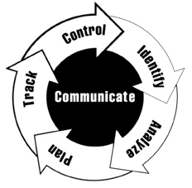
Risk and opportunity go hand in hand. Many development projects strive to advance capabilities and achieve something that hasn't been done before. The opportunity for advancement cannot be achieved without taking risk.

"Risk in itself is not bad; risk is essential to progress, and failure is often a key part of learning. But we must learn to balance the possible negative consequences of risk against the potential benefits of its associated opportunity."
Risk Management is the process of identifying, analyzing and mitigating risk. A forward-looking approach will be taken by the project by conducting a series of project and business risk assessments. The project risk assessments goal will be to identify and analyze all risk elements to the main project and effectuate necessary activities.
- assess continuously what can go wrong (risks).
- determine what risks are important to deal with.
- implement strategies to deal with those risks.

Solution delivery
Solution administration
Sale
Product innovation
Primary processes
Supporting processes
Resource Management
Personnel
Quality Improvement
Project Management
Economy Management

Figure 16 Process overview

Microsoft Solution Framework

The overall idea in the quality framework in the context of development and delivery projects is to promote an iterative development of functionality with incremental deliveries to the customer. The focus when defining the increments is on functionality that provides most benefit for the customer compared to the development work involved and on functionality that is critical for the system to work. By this approach we try to reduce the risk inherent in large development and delivery projects. The incremental deliveries to the customer provide fast feedback on any deviation between the customer expectations and the delivered product, while the iterative development provides fast feedback on problems encountered during the development. The increments can by anything from a document to a prototype or a partial functional system.

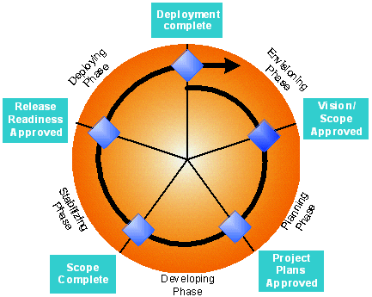

Figure 17 Development phases in an iterativ process
The structuring of the overall project delivery into increments is an important activity in the project and done in close cooperation with the customer’s key personnel.

The Team model inherited from MSF improves the overall competence control in the project and the communication with the same roles at the customer secures that the different aspects of the project is covered.

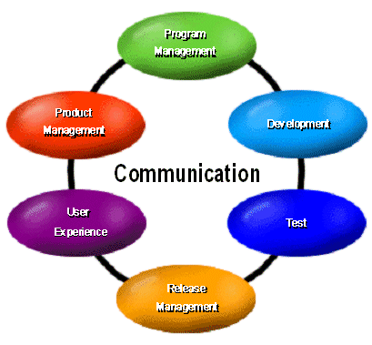

Rational Unified Process

In addition to the processes in the quality framework, additional processes are used in the development work in a project. .............................................
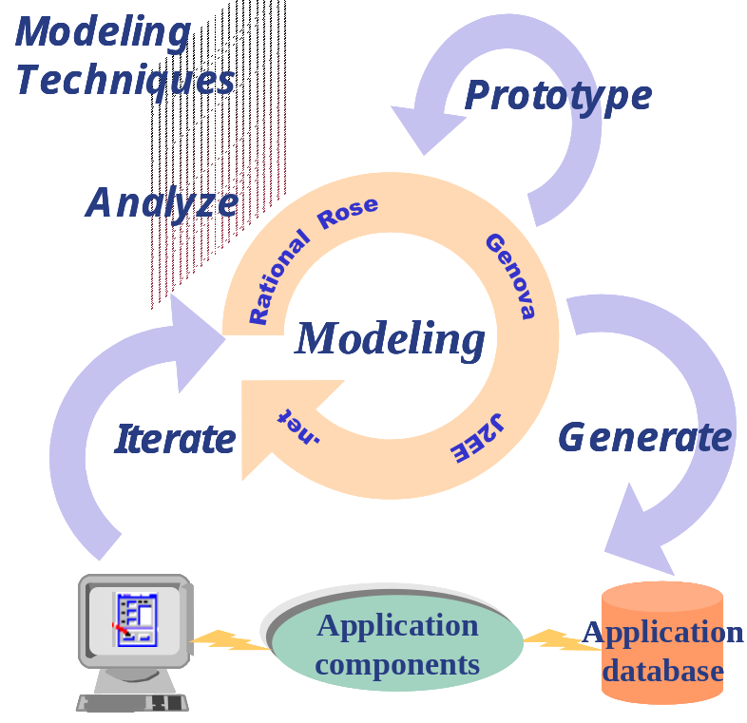
Figure 18 System development process

The quality framework provides the necessary tools for the projects to control and verify that the expected quality of the work and work products is achieved; the project organization can use standard quality tools like reviews, inspections and walkthrough or automatic test equipment. The framework also provides procedures for risk management, change order control and also recommend tools or mechanism to simplify the actual work.
To secure process adherence in the project organization, projects are regularly reviewed either by internal or external quality experts according to the terms of the contracts.

A basic requirement for the overall project success is that the solution is developed in accordance with the needs of the stakeholders, to provide efficient and flexible solutions to real problems.

.................................... and their partners in this project are used to work on projects where the requirement specification covers hundreds of pages of details. However, during years of experience in this area the only conclusion is that it is only in direct cooperation with the different users and stakeholders that the real design can be done. The process selected for the NCSIS project is based on a close cooperation with MOIM to design and develop the best possible solution within the given frames of time and cost.

Our solution architects and functionality advisors have outstanding experience from projects where all workflows are analyzed and optimized to create maximum user satisfaction in the delivered solution.
An important aspect of the workflow reengineering is to create different prototypes of various aspects of the solution before actual implementation. Based on the customers experience with these prototypes a number of details and problems can be resolved before the requirement specification is closed and the implementation starts.

